**DATA TRANSFER IN MIPS**

**LAB # 04**



**Fall 2023**

**CSE-304L Computer Organization and Architecture Lab**

Submitted by: **Ali Asghar**

Registration No.: **21PWCSE2059**

Class Section: **C**

“On my honor, as student of University of Engineering and Technology, I have neither given nor received unauthorized assistance on this academic work.”

Submitted to:

**Dr. Bilal Habib**

Date:

**27th October 2023**

**Department of Computer Systems Engineering**

**University of Engineering and Technology, Peshawar**

**ASSESSMENT RUBRICS COA LABS**

|  |  |  |  |  |
| --- | --- | --- | --- | --- |
| **LAB REPORT ASSESSMENT** | | | | |
| **Criteria** | **Excellent** | **Average** | **Nill** | **Marks Obtained** |
| 1. **Objectives of Lab** | All objectives of lab are properly covered  [Marks 10] | Objectives of lab are partially covered  [Marks 5] | Objectives of lab are not shown  [Marks 0] |  |
| 1. **MIPS instructions with**   **Comments and proper indentations.** | All the instructions are well written with comments explaining the code and properly indented  [Marks 20] | Some instructions are missing are poorly commented code  [Marks 10] | The instructions are not properly written  [Marks 0] |  |
| 1. **Simulation run without error and warnings** | The code is running in the simulator without any error and warnings  [Marks 10] | The code is running but with some warnings or errors.  [Marks 5] | The code is written but not running due to errors  [Marks 0] |  |
| 1. **Procedure** | All the instructions are written with proper procedure  [Marks 20] | Some steps are missing  [Marks 10] | steps are totally missing  [Marks 0] |  |
| 1. **OUTPUT** | Proper output of the code written in assembly  [Marks 20] | Some of the outputs are missing  [Marks 10] | No or wrong output  [Marks 0] |  |
| 1. **Conclusion** | Conclusion about the lab is shown and written  [Marks 20] | Conclusion about the lab is partially shown  [Marks 10] | Conclusion about the lab is not shown[Marks0]  [Marks 0] |  |
| 1. **Cheating** |  |  | Any kind of cheating will lead to 0 Marks |  |
| Total Marks Obtained:__________  Instructor Signature: ______________________ | | | | |

**Task 1:**

Load a value from memory and add 10 to it. Store the result back in memory and show the result on console. ( *hint: use MIPS instructions lw and sw*)

**Code:**

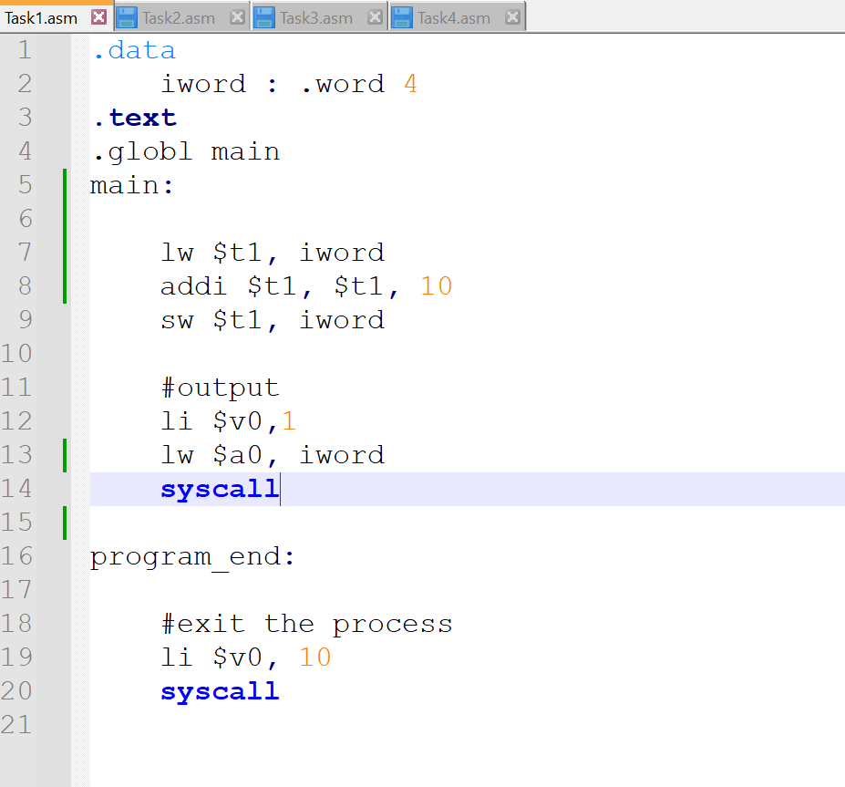

**Output:**

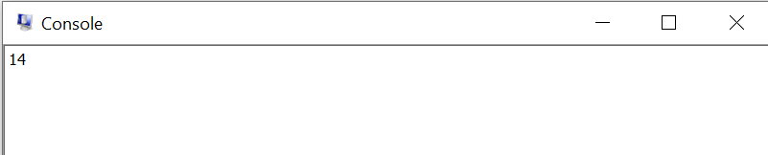

**Task 2:**

Load a value from memory and double it. Store the result back in memory also show on the console. (*use sll, sw and lw*)

**Code:**

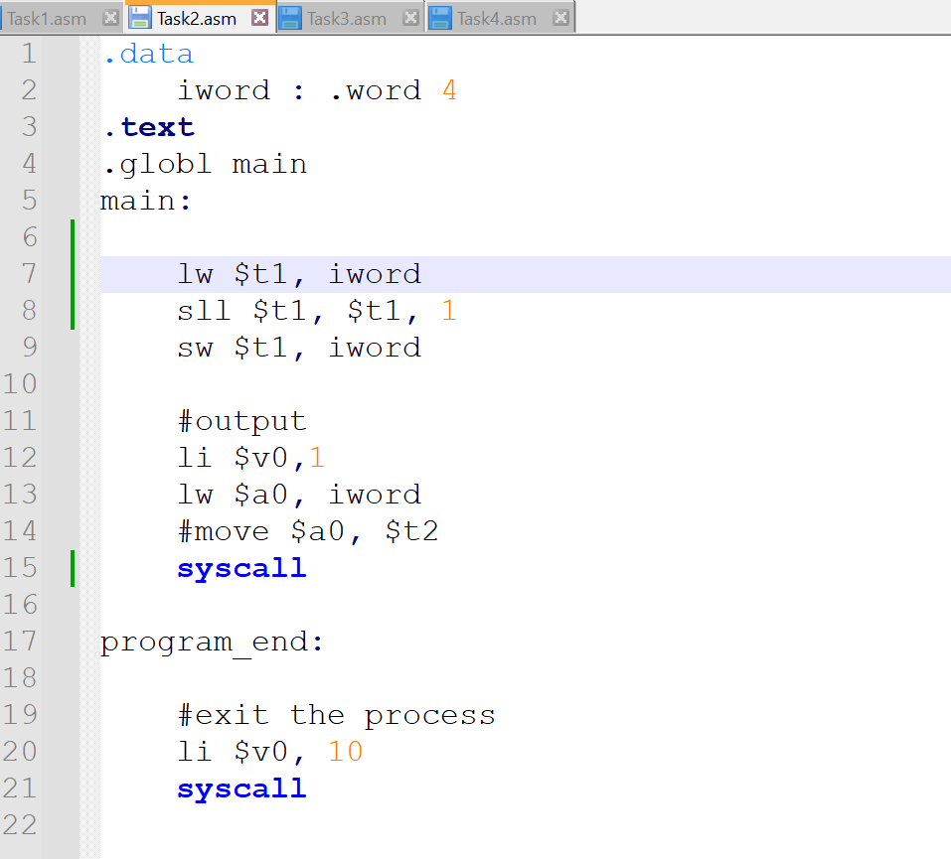

**Output:**

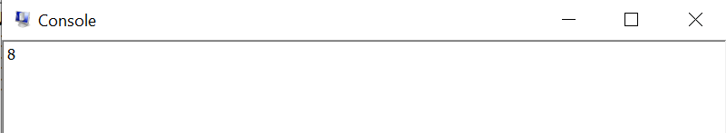

**Task 3:**

Load an address of a label into a register and jump to that address and perform addition in that address. .(use jr(jump register) )

**Code:**

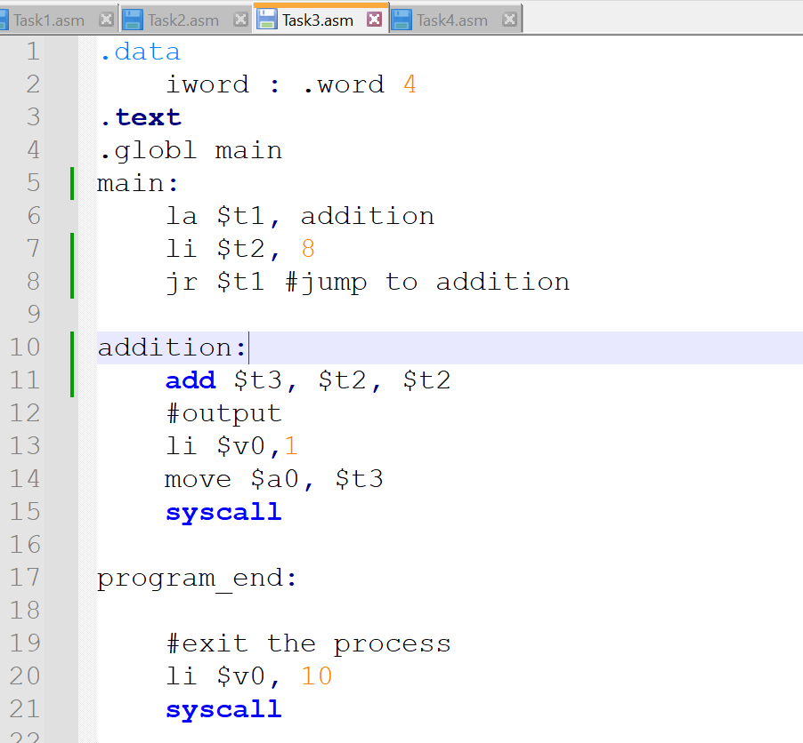

**Output:**

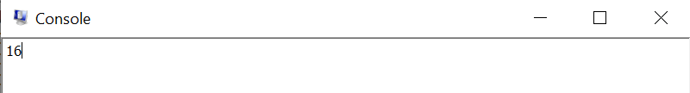

**Task 4:**

Write assembly program to find the Fibonacci series.

0, 1, 1, 2, 3, 5, 8, 13, 21, 34, ...

Users will be asked to enter a number, for instance 9. Then assembly will print the first 9 numbers of Fibonacci series.

**Code:**

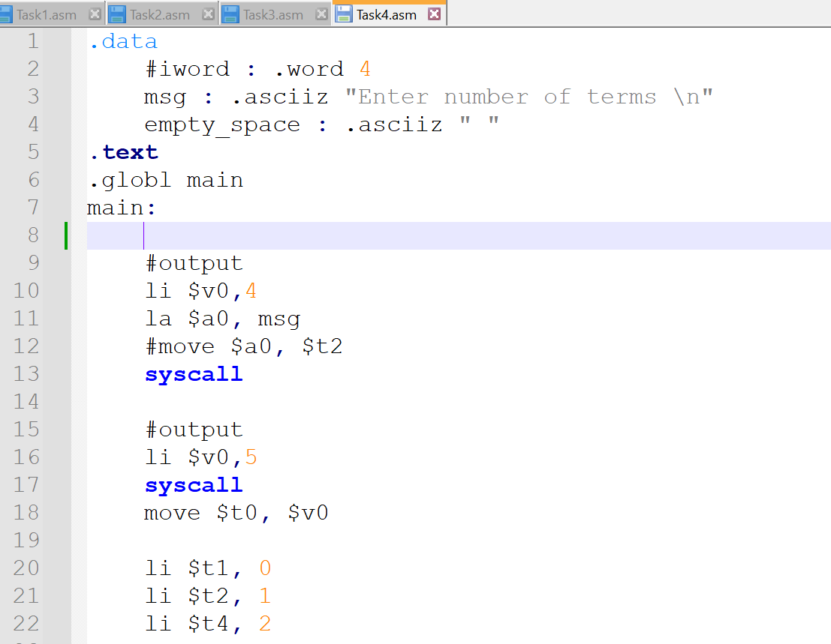

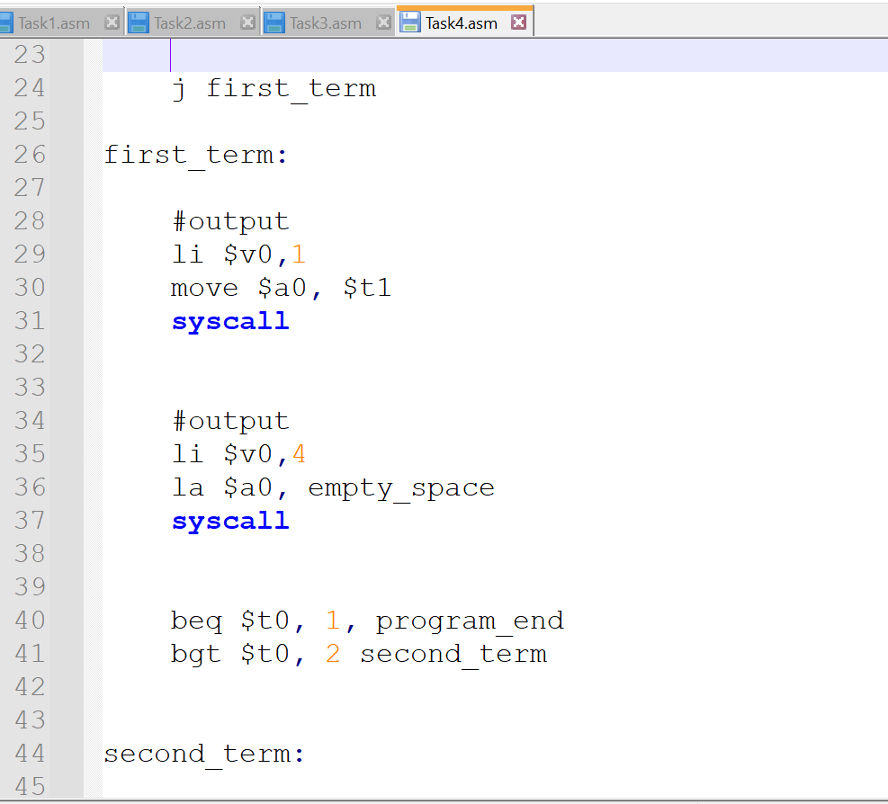

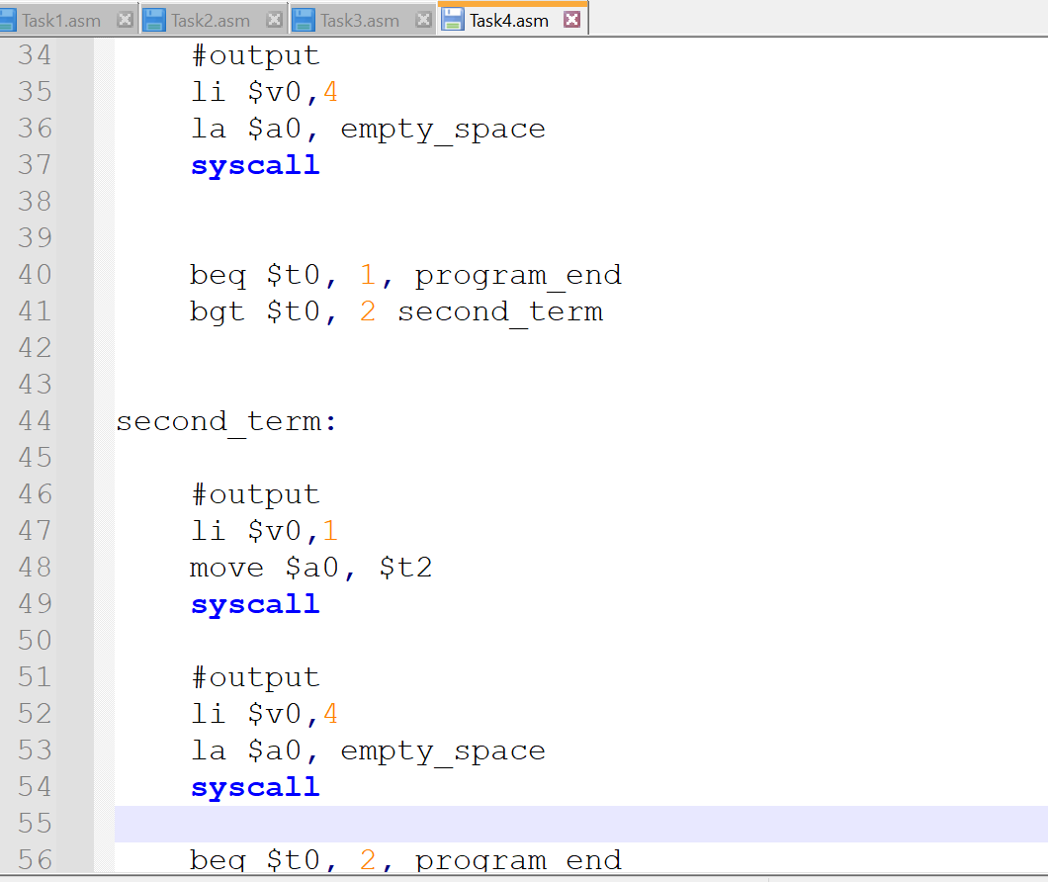

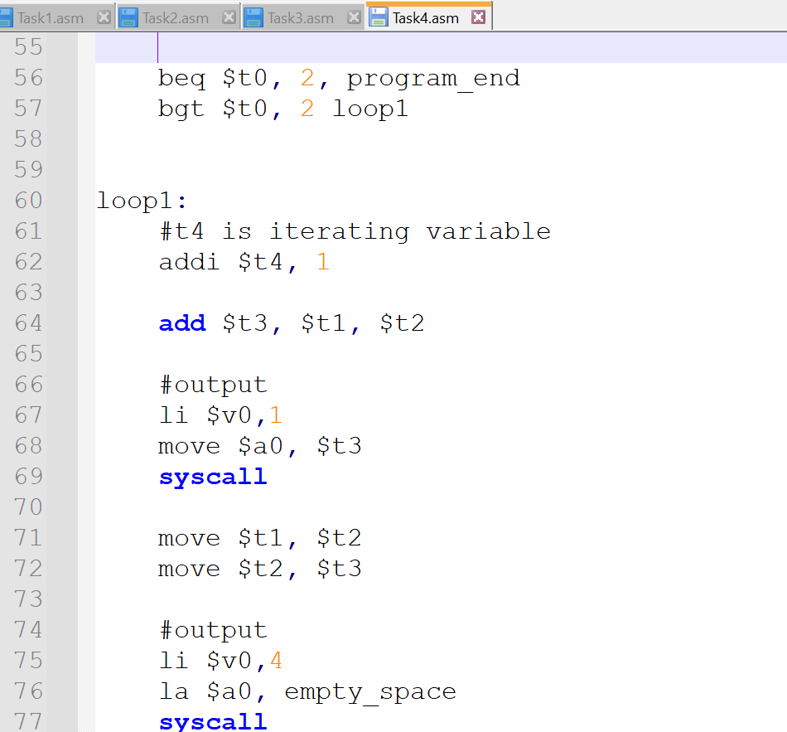

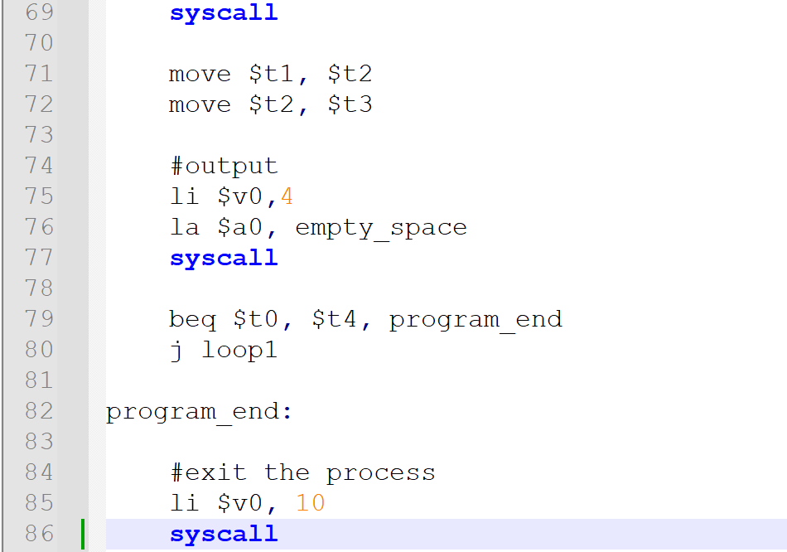

**Output:**

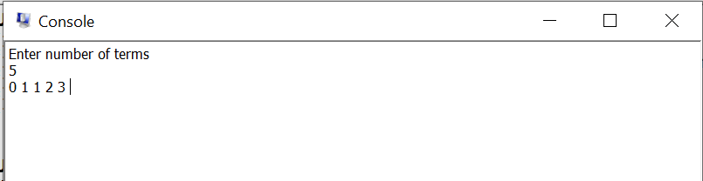

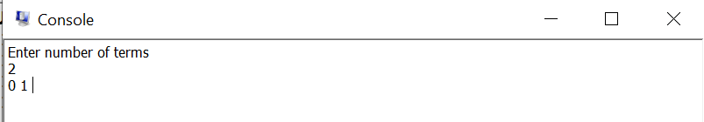

**Conclusion:**

In this lab, I learned about the storing and loading instructions(lw and sw) in MIPS Assembly.